Structure Of Health App(website)

Save Detail of Registration Form in Database(mysql)

Register Form

Website Of Home Page

Heart Disease Page

Liver Disease Page

Diabetes Disease Page

Predict Heart disease (result page)

Predict Diabetes disease (result page)

Predict Liver disease (result page)

Main View of Website (Home Page)





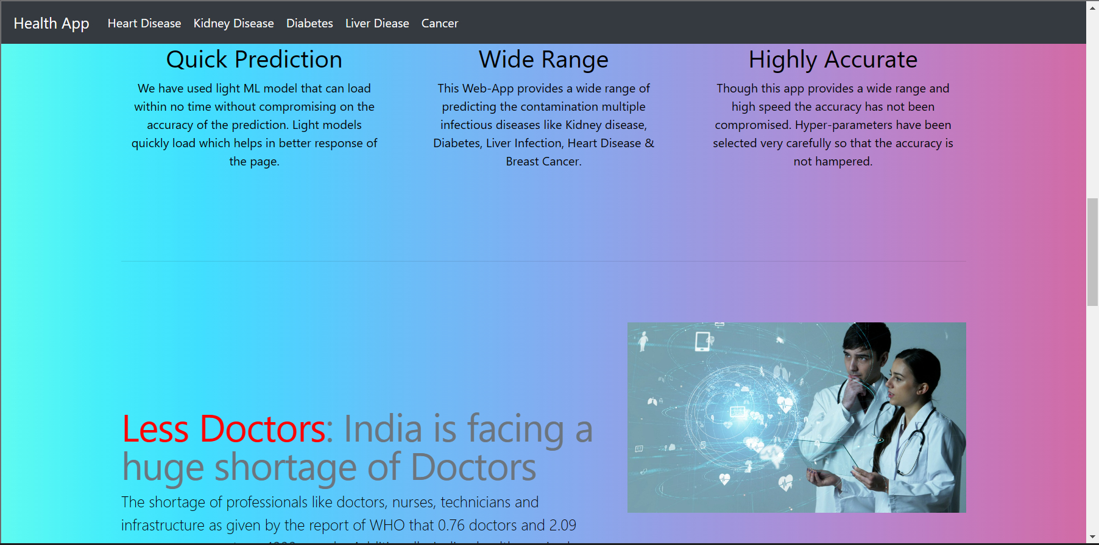

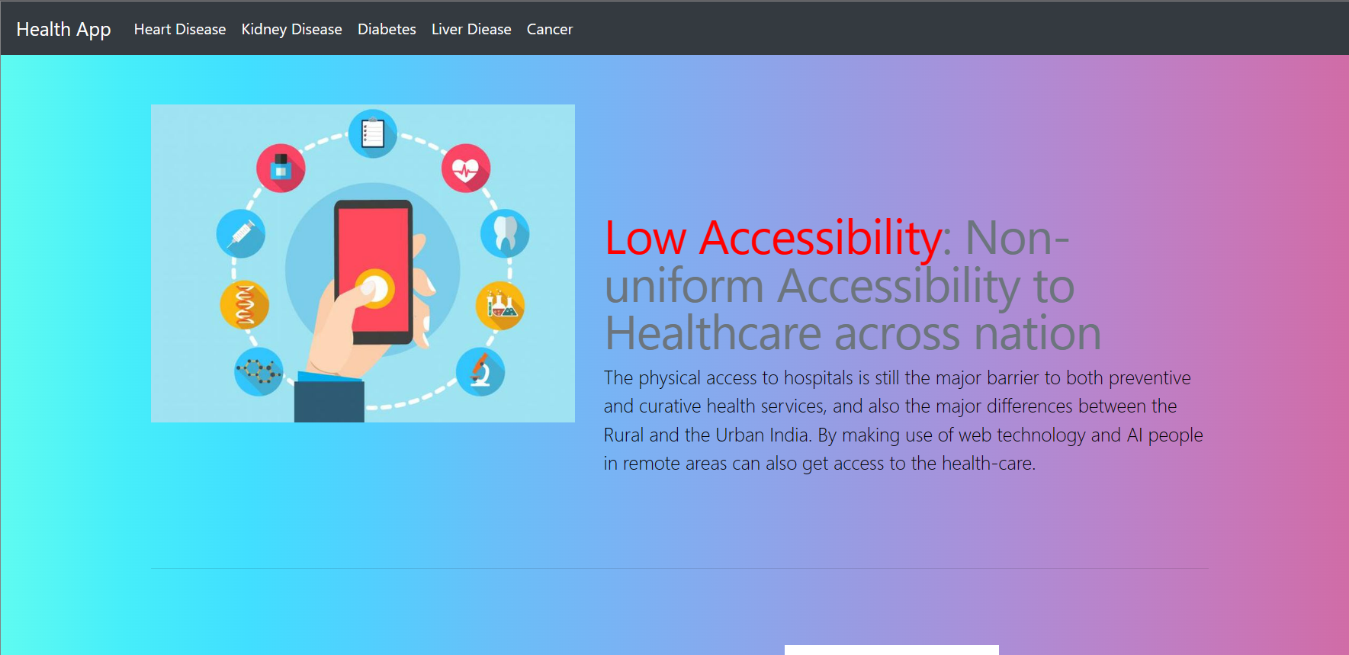

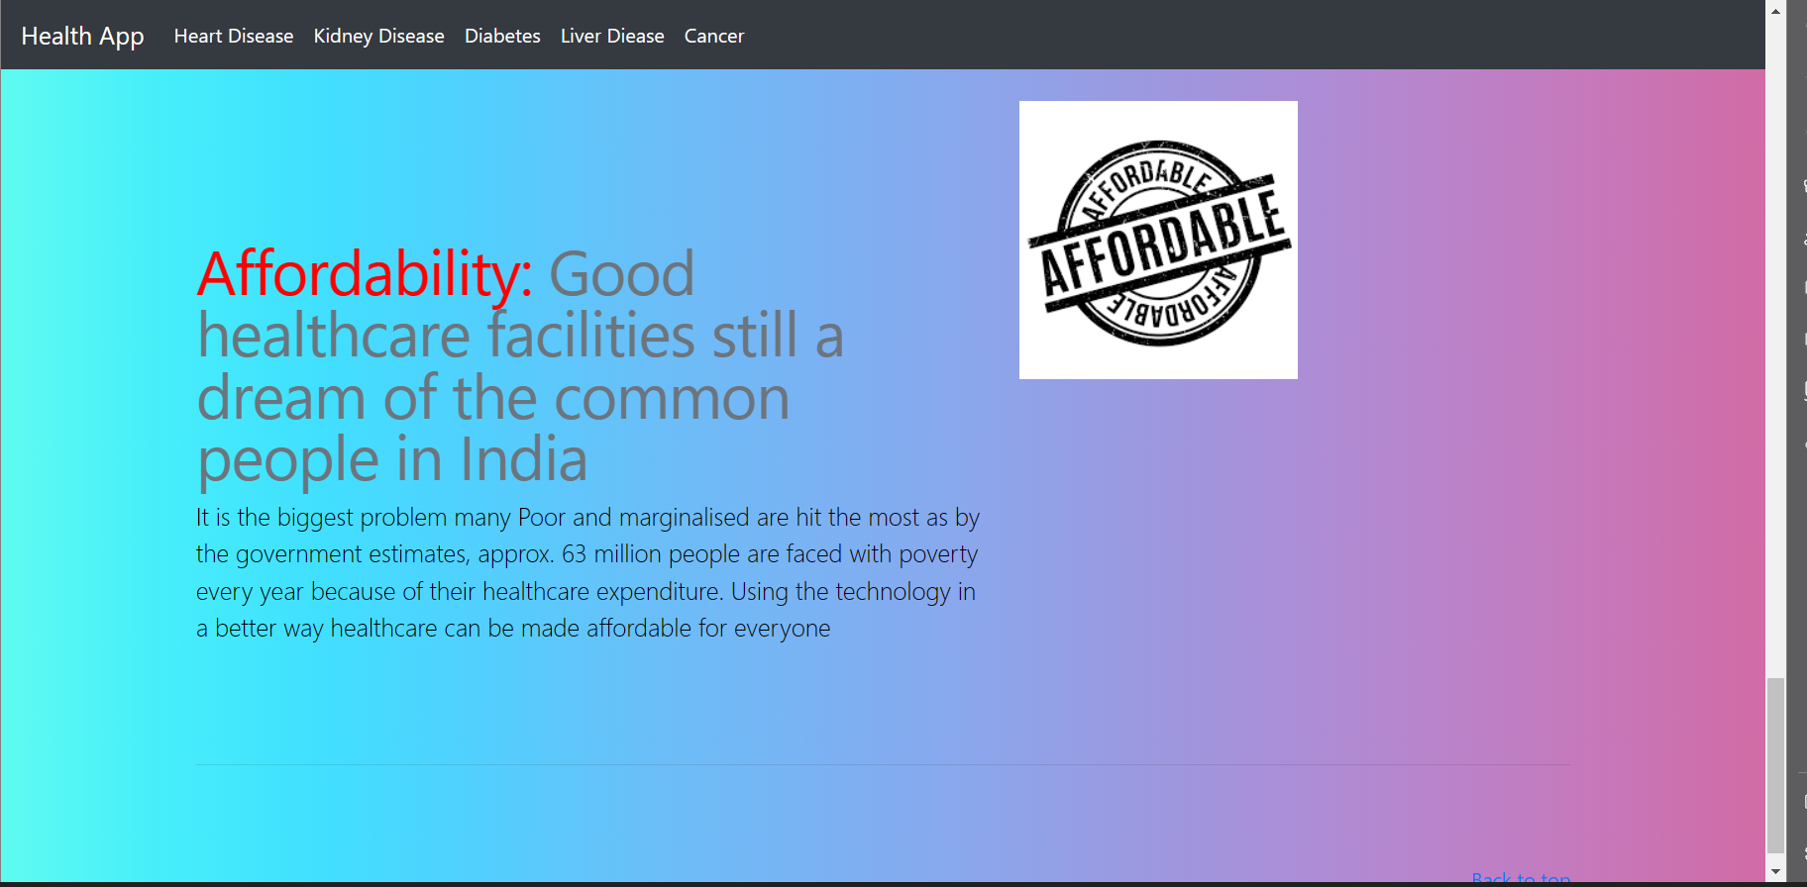

After click any disease the open registration form to fill the basic detail in database and redirect the disease which you choose the disease option(diabetes page)

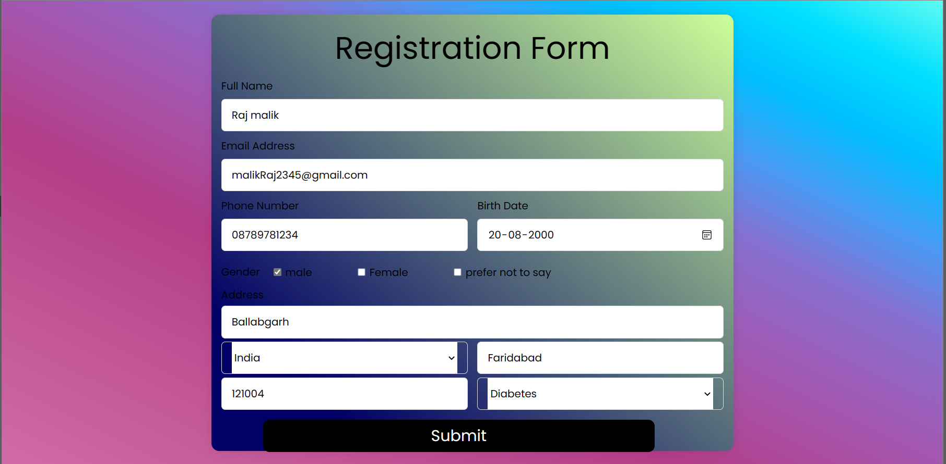

Predict diabetes page

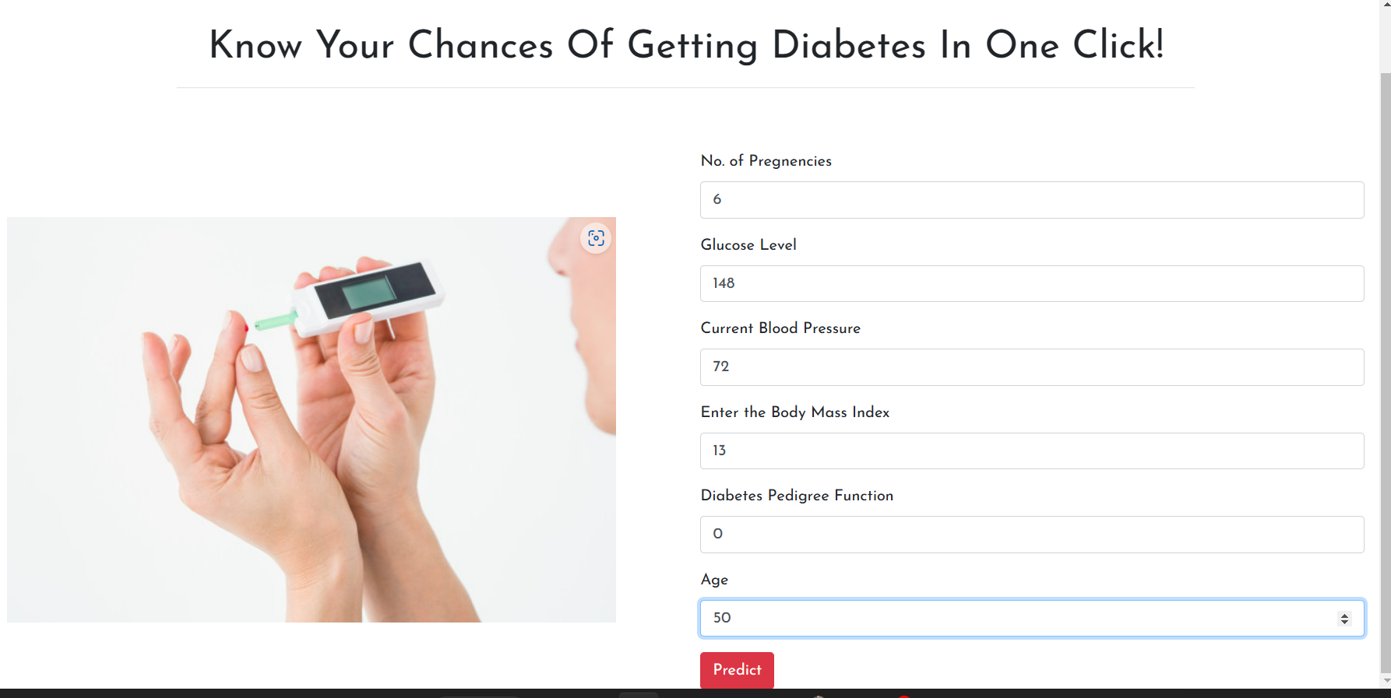

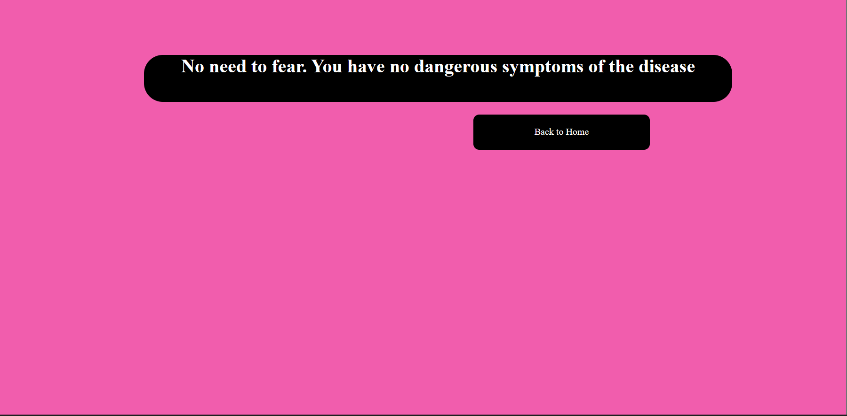

Kidney predict page

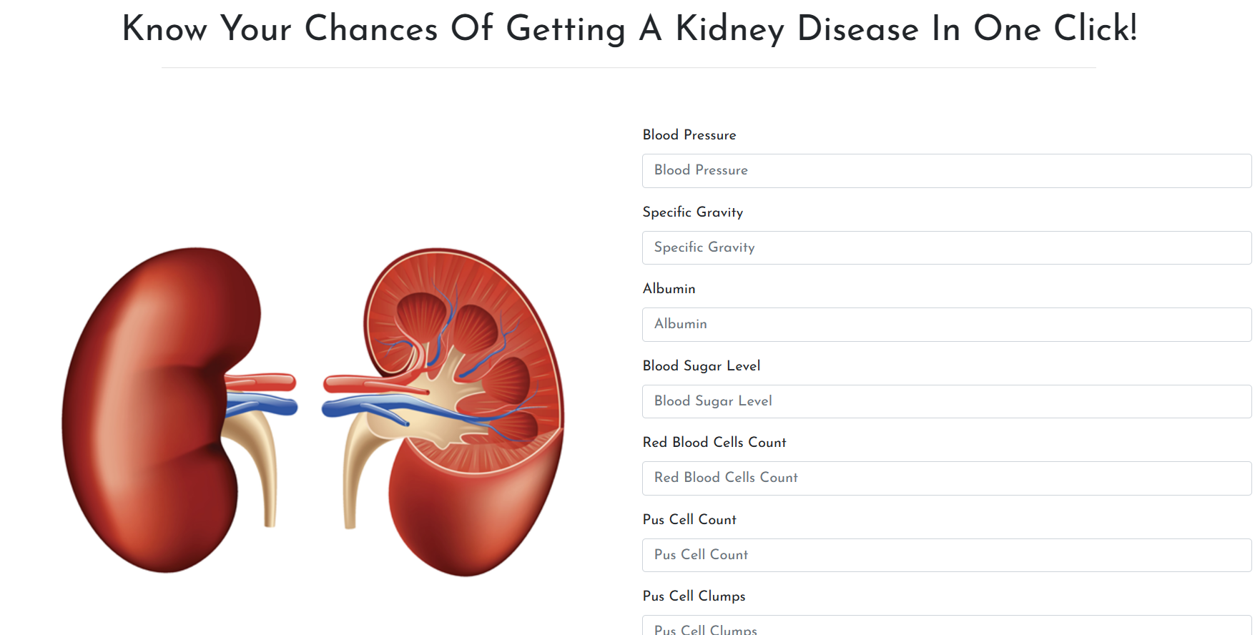

Heart page

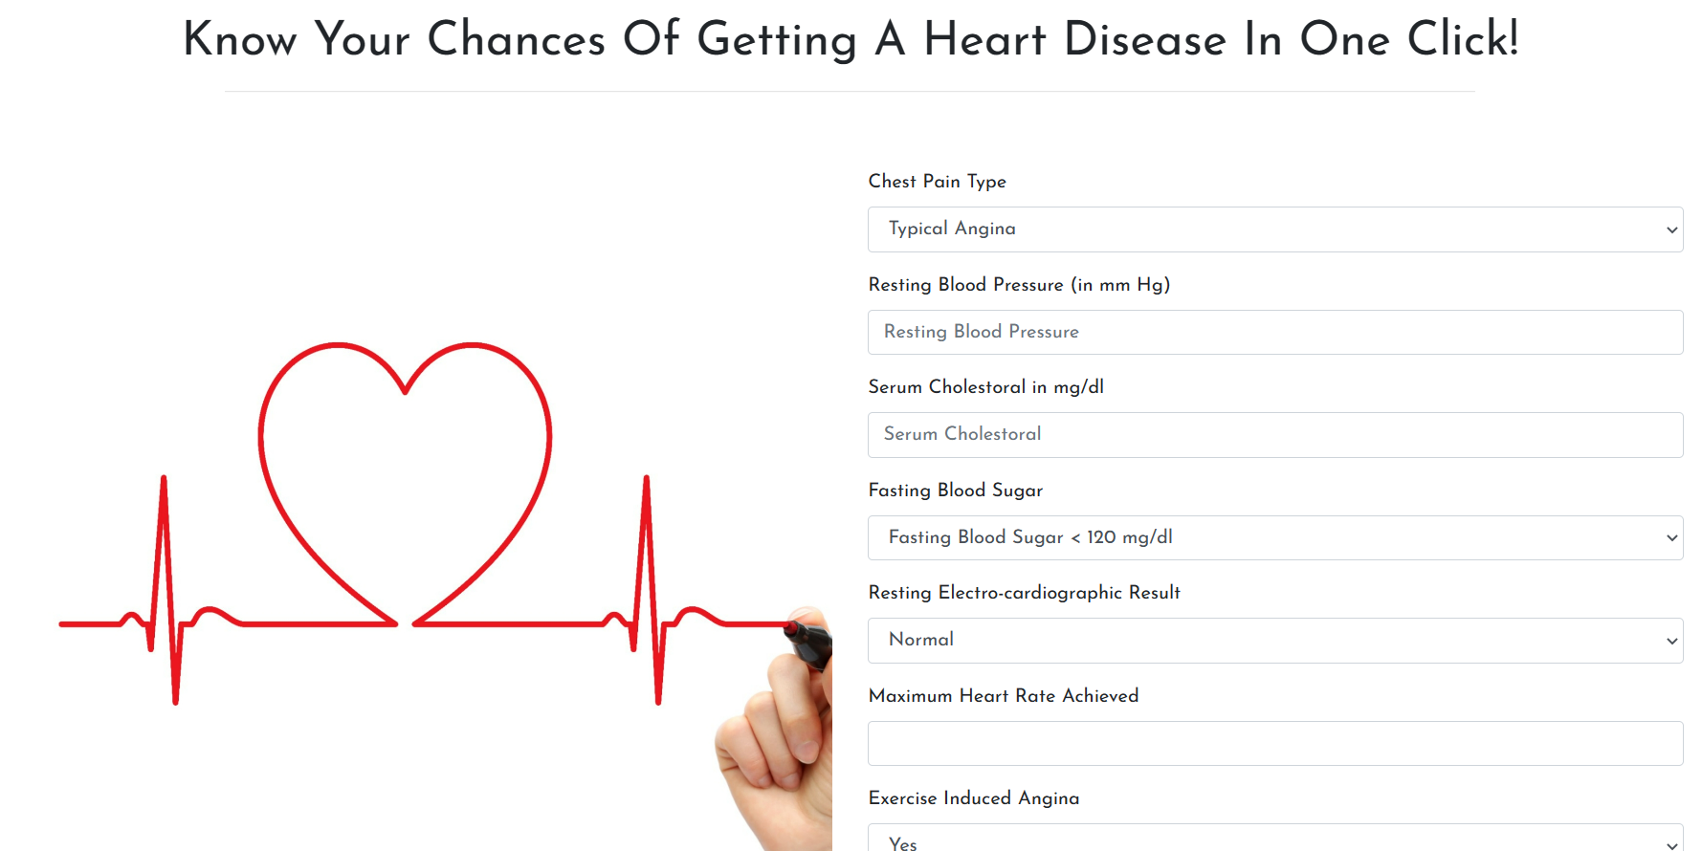

Liver Page

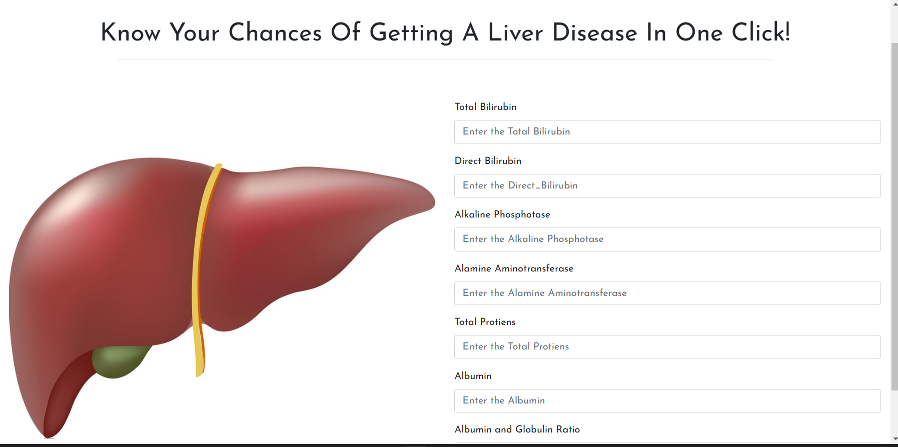

Cancer Page

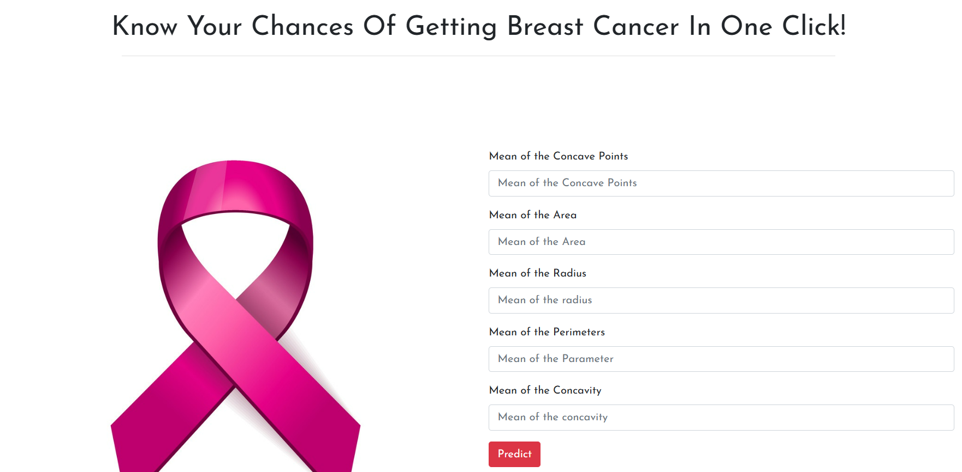

Database page of Register Form

